Real Men Iowa 2022

March 4, 2022 – 7PM

Speaker: Dave Fremstad

Worship: John Frerichs

Pathway Church

6523 Merle Hay Rd, Johnston

Register $10 at www.realmeniowa.org
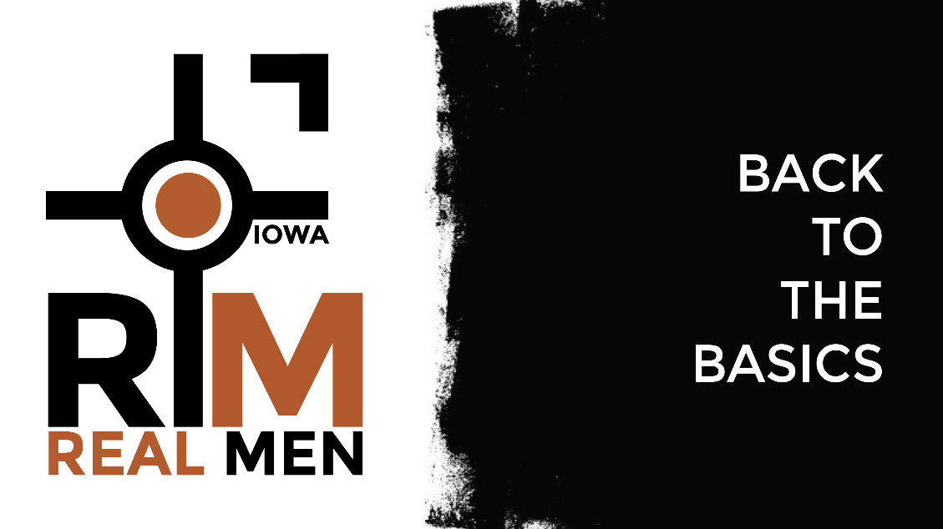

Real Men Iowa 2022

March 4, 2022 – 7PM

Speaker: Dave Fremstad

Worship: John Frerichs

Pathway Church

6523 Merle Hay Rd, Johnston

Register $10 at www.realmeniowa.org
